**Project Development Sprint-2**

|  |  |
| --- | --- |
| **Team ID** | PNT2022TMID02439 |
| **Project Name** | SmartFarmer - IoT Enabled Smart Farming Application |
| **Team Members Name** | Kamesh Kumar K , Kaviyaraj C ,  Javeed Akram Z , KavinSaran JK |

# Flow:1

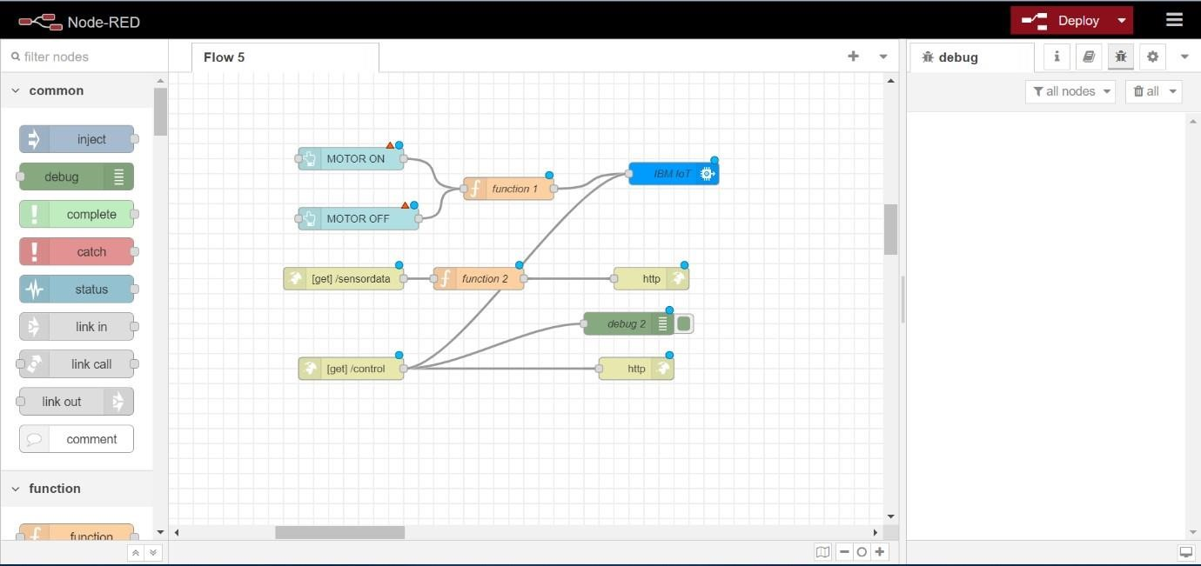

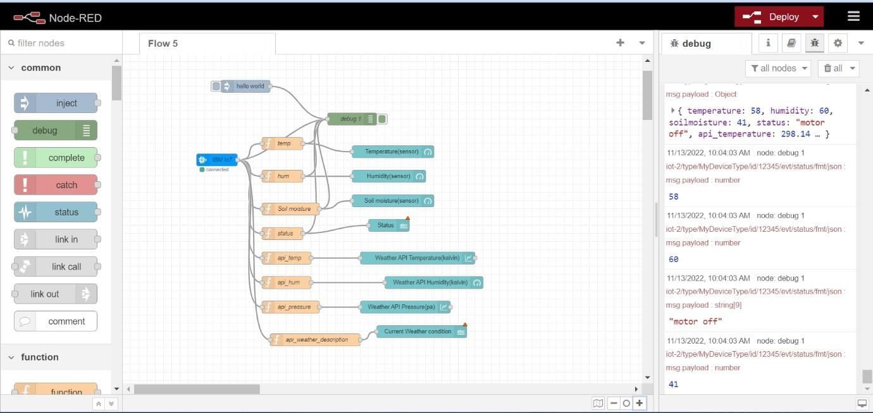

**Flow:2**

# Flow:1 Configuring All Nodes With IBM IOT Platform

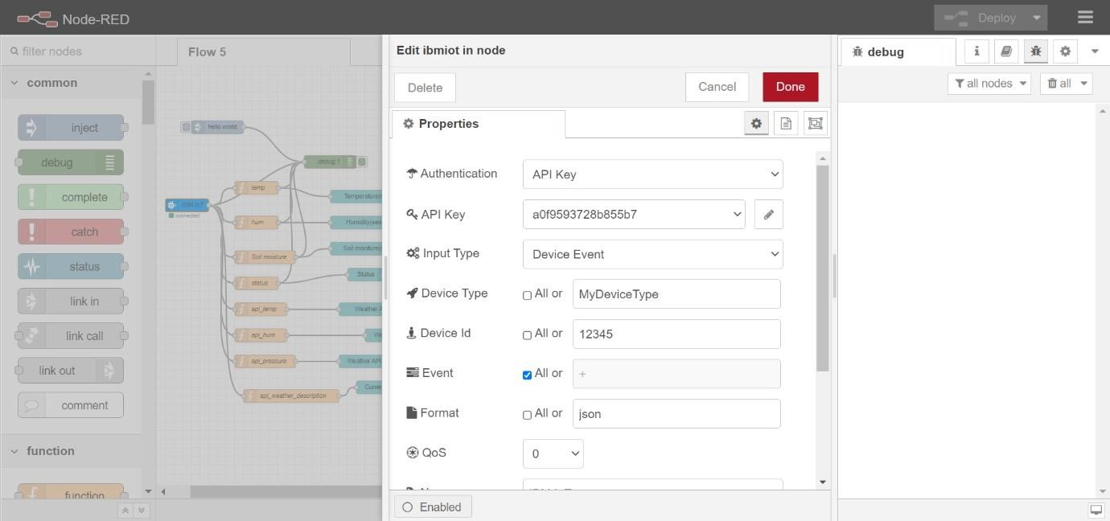

# Flow:2 Configuring All Nodes With IBM IOT Platform

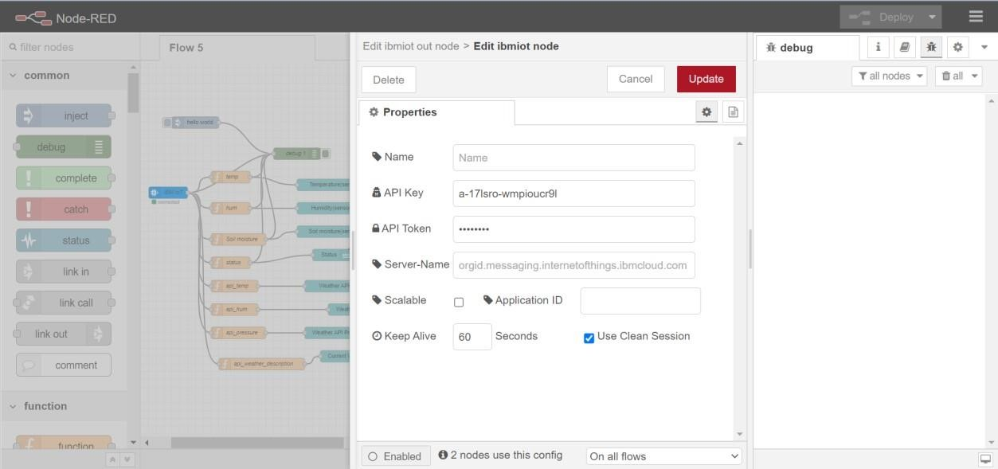

# Execution of Python Program

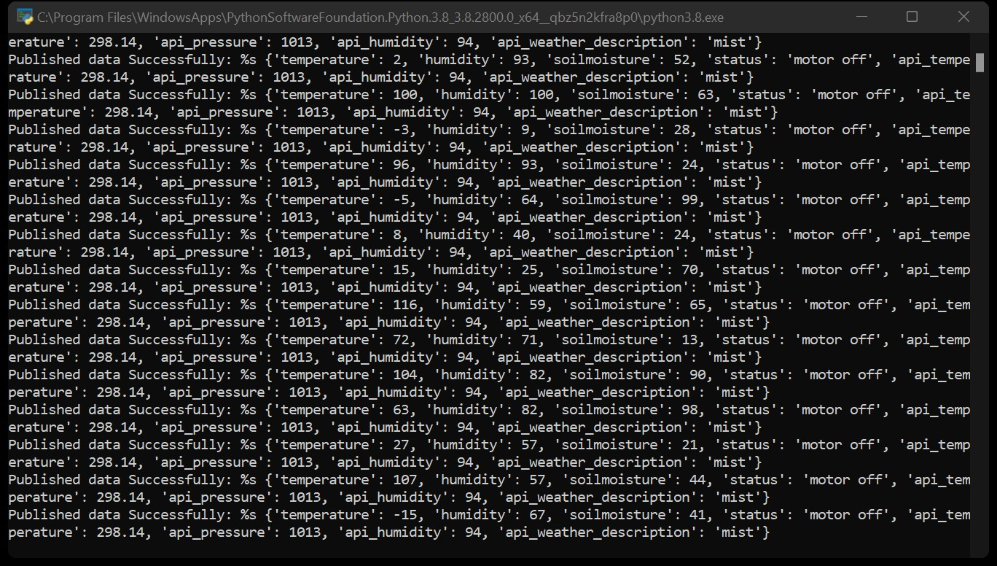

# Web UI Output

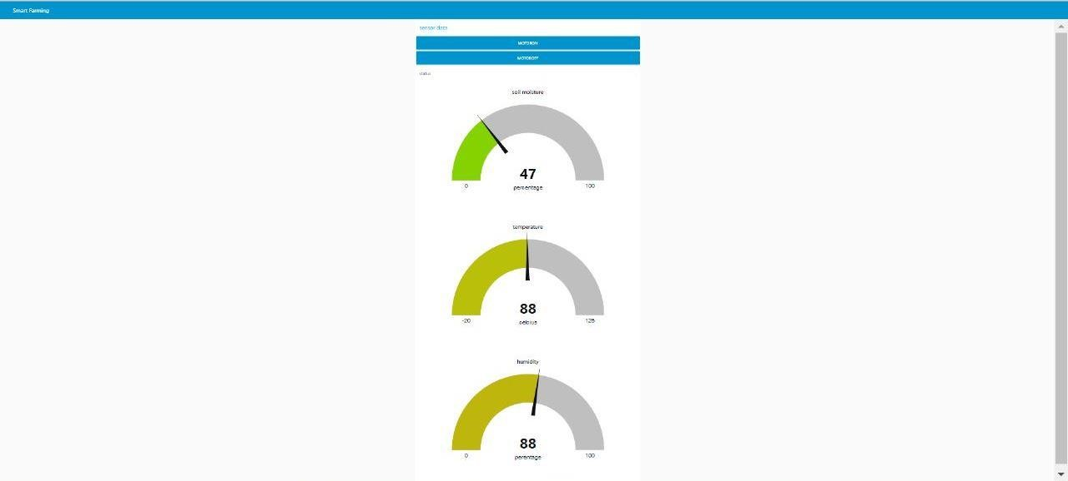

# IBM Watson IoT Platform Device Connect & Live Data

